0000.doc  Using RADTAC Atern template version 1.0 | Author: <<Author Name>> | <<date>> | 9 pages

Click here and type Project Name  System Architecture Definition  (part of the Solution Foundations product)  (v0.0) |  | 
Purpose of this document
- To provide a common understanding of the technical architectures to be used during development and deployment of the solution including:
  - Hardware/Infrastructure
  - Software Architecture
- To describe the target environment for the solution and (if different) the development environment.
- To provide an outline description of anticipated developments in areas such as:
  - Hardware (i.e. the infrastructure, processing, storage, networking etc.) for both development and deployment
  - Software (i.e. the major software objects or components - both process and data - and their interactions)
  - Information Security (e.g. access policy, access control etc.)

Approved/Accepted by
<<Name>> Technical Coordinator | date | <<Name>> Project Manager | date
<<Name>> <<Role>> | date | <<Name>> <<Team Leader>> | date
<<Name>> <<Role>> | date | <<Name>> <<Role>> | date

Revision History
Name | Ver | Reason for change | Status | Date
Table of Contents
1. System Architecture 3
1.1 Architecture Overview 3
1.2 Hardware Components and Relationships 3
1.3 Software Components and Relationships 3
1.4 Non-Functional Requirements 5
1.5 Maintainability Considerations 6
2. Technical Environments 7
2.1 Development Platform 7
2.2 Target Platform 7

System Architecture

Architecture Overview
This project aims to create a database evaluator which will diagnose and check the basic implementation parameters of SQL Server Instances and Databases. A more detailed list of the outputs of the project are as follows:
- A Client Application that will produce a dump file containing details about a customer’s SQL Server database and instance parameters.
- A product website where the customer can download the Client Application and upload the SQL Server dump files generated by the Client Application.
- A Database Evaluator tool that will generate SQL Server evaluation reports using the data from the dump files uploaded by customers.

Hardware Components and Relationships
There are no hardware components involved in this project. Any machine that can run SQL Server can be used.

Software Components and Relationships
This project involves three software components which are as follows:
- Product Website
- Client Application
- Database Evaluator
In the Database Evaluator System, there are also two main personas involved namely:
- The Customer
- The Project Team
The relationship between the software components and the personas is describe in the succeeding diagram.
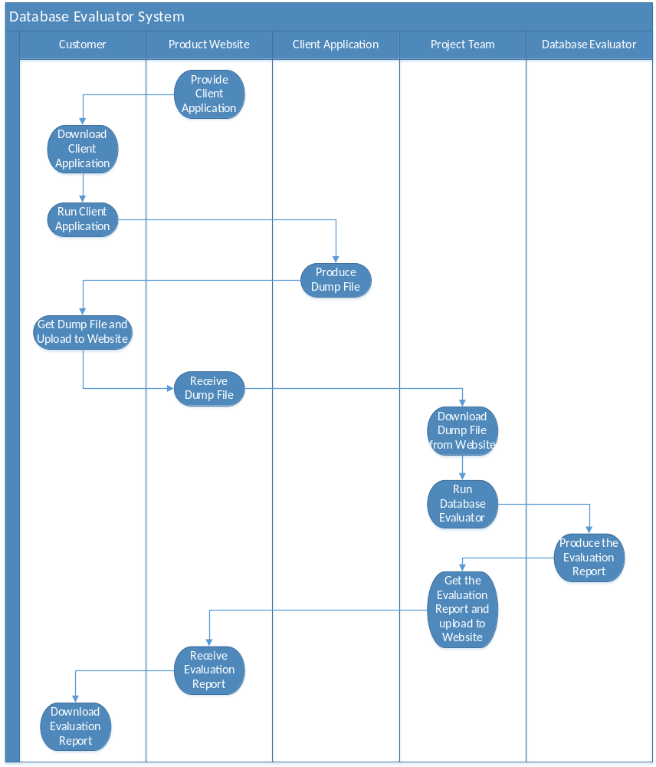

Non-Functional Requirements
Non-functional requirement | Priority  1=critical  2=important  3=unimportant | How this is supported by the architecture
Usability | 2 | • The client application and database evaluator will only run on a Windows environment.  • “About” and “Help” information about the product must be retrievable at any point during the use of the application.  • In the client application, the customer must be able to choose the SQL Server name that needs to be evaluated from a list. A green mark must be there to indicate that the connection is successful.  • In the client application, the customer must be able to choose the SQL Server name that needs to be evaluated from a list. A green mark must be there to indicate that the connection is successful.  • The client application must be downloadable from the product website.  • The customer and project team must be notified if a dump file or an evaluation report is uploaded.  • In the website, any changes or submitted parameter values from the customer should all be available in the account user page for customer to see.  • The website is platform independent. It should be supported by all web browsers.  • In the website the customer should be able to register first to use the Client Application.  • In the website the customer should be able to use contact page in any case an inquiry regarding the system or website is needed.  • In the website the customer should be able to download a pdf documentation on how to use the Client Application.
Performance | 1 | • The client application must collect the parameter values without any error. It should not also modify any existing values.  • The encrypted dump file must successfully upload on the website without any error.  • The database evaluator will check and produce the evaluation report without any errors.  • The website should be able to record the customer information and validation for any error information.  • The website should be able to download parameter values from the customer and upload results.
Capacity | 2 | • The client application and database evaluator should be light weight and should not use too much RAM and disk space. It should also not invoke too much processes to make the system hang.  • The website should be able to accommodate around 300 users.
Scalability | 2 | • The capacity of the website is limited by the hardware and software currently installed in the target machine.
Security | 2 | • The dump file will be encrypted using a key.  • The website will require login credentials from users before the users can be able to upload and view files.  • The website will require valid email address to be able to register and upload parameter values.
Availability & peak usage | 2 | • The website should be available to the specified amount of users at all times if possible.
Resilience & recovery | 3 | • If time will permit, a recovery plan will be established to back-up the database and other needed files after a set period of time.
Supportability | 2 | • The client application and database evaluator can only be run on a Windows machine with the .NET framework installed.  • The client application and database evaluator should support the SQL Server 2008 R2 and SQL Server 2012.  • The website should be compatible with all popular web browsers.
Implementation | 2 | • The client application and database evaluator will be developed using C#.  • SQL Server 2008 R2 and SQL Server 2012 will be used for creating the databases and the SQL scripts.  • The website will be created using Wordpress, PHP, Javascipt, HTML, CSS and MySQL.

Maintainability Considerations
To ensure the maintainability of the software being created, some coding standards will be followed as follows:
- Comments
Comments will be placed throughout the code base to ensure that the different functions and logic involved can be easily understood by future developers.
- Code Formatting
The code will be formatted as per standards to enhance the readability of the programs.
- Testing
There will be regular testing of functionalities to ensure that everything works as per design and no previous features are broken by newly created ones.
- Documentation
All software produced would have their corresponding technical documentation to give an overview of how it works and how it is structured.

Technical Environments

Development Platform
The developers are using machines and software with the following specifications:

Hardware
Operating system | Windows 10
CPU | Intel(R) Core(TM) i7-4790
Memory | 8 GB RAM
Hard drive | 500 GB

Software
IDE | Microsoft Visual Studio Enterprise 2015 Update 1  Eclipse for PHP Developers Release 4.5.2
Web Development | XAMPP for Windows Version 5.6.21  PHP 5.6.21  phpMyAdmin 4.5.1  MariaDB 10.1.13  Apache 2.4.17
Windows Form Development | Git version 2.9.2  Install Shield 2015 Limited Edition  SQL Server 2016  SQL Server 2016 Management Studio

Target Platform
The requirements for the target platforms are detailed as follows:

Website Server Machine
Operating System | Windows XP or higher
CPU | Pentium 4 1.5 GHz or Athlon XP 1500+ processor or higher
Memory | 2 GB RAM
Hard Drive | 500 MB available in the hard disk
Software | PHP 5.6.21  MariaDB 10.1.13  Apache 2.4.17

Client Application Machine
Operating System | Windows XP or higher
CPU | Pentium 4 1.5 GHz or Athlon XP 1500+ processor or higher
Memory | 2 GB RAM
Hard Drive | 500 MB available in the hard disk
Software | .NET Framework 4.5.2

Database Evaluator Machine
Operating System | Windows XP or higher
CPU | Pentium 4 1.5 GHz or Athlon XP 1500+ processor or higher
Memory | 2 GB RAM
Hard Drive | 500 MB available in the hard disk
Software | .NET Framework 4.5.2  SQL Server 2016

